**CHAPTER 1**

**COMPANY PROFILE**

**Chapter 1**

**COMPANY PROFILE**

**1.1 About Company**

Société Générale Global Solution Centre is part of Société Générale, a leading financial services group founded in 1864. The company operates using a diversified universal banking model, combining financial strength with sustainable growth strategies to support the economy and customer projects

Founded by a group of entrepreneurs in 1864 “to promote the development of trade and industry in France”, Société Générale is today one of the leading European financial services groups. Based on a diversified and integrated banking model, the Group combines financial strength and proven expertise in innovation with a strategy of sustainable growth, aiming to be the trusted partner for its clients, committed to the positive transformations of society and the economy.

Active in the real economy for over 150 years, with a solid position in Europe and connected to the rest of the world, Société Générale has over 117,500* members of staff in 66 countries and supports on a daily basis 25* million individual clients, businesses and institutional investors around the world by offering a wide range of advisory services and tailored financial solutions.

The Group is built on three complementary core businesses:

* **French Retail Banking**, which encompasses the Société Générale, Crédit du Nord and Boursorama brands. Each offers a full range of financial services with omni-channel products at the cutting edge of digital innovation;
* **International Retail Banking**, Insurance and Financial Services to Corporates, with networks in Africa, Central and Eastern Europe and specialized businesses that are leaders in their markets;
* **Global Banking and Investor Solutions**, which offers recognized expertise, key international locations and integrated solutions

Team spirit, innovation, responsibility and commitment are the core values shared by all Société Générale employees. These values are central to our vision of a relationship-focused bank committed to serving its customers.

As a responsible financial services group, the fairness and integrity of our practices are at the core of our relationship-building approach. Ensuring compliance with these principles is our responsibility towards our customers. It also helps us earn their trust and protects our Group’s reputation

**1.2 Vision Statement**

Société Générale Group is committed to build together, with its clients, a better and sustainable future. This strategy is set of four pillars: the urgency of energy transition, having positive local impact, acting as a responsible employer, and maintaining a culture of responsibility

**1.3 Key Industries**

We accompany large corporate clients in their growth and development by offering them strategic advice and financing solutions. Our Corporate & Investment Bank provides expertise in strategic advisory, mergers & acquisitions, equity capital markets and strategic equity transactions.

In the Asia Pacific region, our Global Finance teams originate and distribute structured finance transactions. We combine sector and industry knowledge together with the technical know-how and structuring skills to bring the right solutions.

**Natural Resources & Energy Finance**

Harnessing our sectoral expertise, we provide a full range of finance and advisory services for producers, traders, processors and end-users of energy, metals and soft commodities through three key platforms:

**Energy Group:** financing and advisory services for energy projects worldwide as well as structured financings and reserve-based lending for energy players

**Metals & Mining Finance:** structured financing and advisory services for metals & minerals sector players as well as financing of large and diversified mining companies

**Traders, Commodity Finance & Agribusiness:** financing of traders and commodity players/processors as well as trade finance to cover traders and commodity players against non-payment risk.

**Debt Capital Markets**

We tailor capital raising strategies to your funding goals, matching your needs to the demands of investors across the world. Our debt capital markets teams aim to raise the finance you need, keeping your funding costs as low as possible. Our insight into capital market conditions and investors’ requirements allows us to advise you on the best capital raising strategies. Through our integrated platform combining multi-product origination, structuring and syndication, we tailor solutions that match your specific goals. Our recognized engineering skills and strong syndication/placement capacities throughout Europe, the United States and Asia, help us to make our clients’ ambitious, innovative financings possible.

**Acquisition Finance and Rating Advisory**

Société Générale’s Advisory & Financing Group team accompanies the bank’s large corporate clients in their strategic and acquisition-related financing needs. We offer financing advisory and funding solutions to support clients in completing their contemplated acquisitions. With a dedicated team located in Hong Kong, the Advisory & Financing Group team can provide acquisition financing solutions with a quick turnaround time for our clients going abroad. Financing can be arranged in various forms and tenors, from bridge loans to term loans, based upon clients’ requirements and deals’ characteristics. The Advisory & Financing Group team also provides rating advice to clients, assisting companies for first-time ratings, rating upgrade and defense and in strategic transaction situations.

**Export Finance**

We deliver financing solutions, risk coverage and advisory services related to import or export contracts whose underlying assets are capital goods, equipment and/or services to companies and financial institutions around the world.

**Infrastructure & Asset Based Finance**

We offer a broad range of products to our clients, whether corporate or public, including capital-raising, risk management and advisory services in, among other areas: Project Finance, Public Private Partnerships (PPPs), Shipping Finance and Aviation Finance.

**Market Services**

We provide hedging, investment and risk advisory solutions for corporate clients globally. Based on an advisory approach, we are able to deliver expert response to risk management, in particular in the realm of foreign exchange and interest rates. Our market services to corporate clients include Market Risk Advisory solutions, Cash & Derivatives services and Investor solutions. Based on a cross-asset approach with customized services, we deliver a comprehensive range of products and solutions across all asset classes, while taking market risk and the evolving regulatory environment into consideration.

**Global Transaction Banking**

For corporates, we provide domestic and international solutions to improve their payment methods, monitor their accounts, manage their transactions remotely and pool their cash. They can benefit from international trade and risk mitigation experts so they can improve their cross-border operations. We offer means to maintain their competitive edge through financing or optimization solutions for their accounts receivables and payables. With its network in more than 50 countries, Global Transaction Banking's local and international teams possess the skills, expertise and in-depth market knowledge allowing corporates to seize all opportunities and make the most of them.

**CHAPTER 2**

**ABOUT THE DEPARTMENT**

**Chapter 2**

**ABOUT THE DEPARTMENT**

**2.1 Overview**

The Federal Reserve System relies on the timely and accurate filing of report data by domestic and foreign financial institutions. The data collected from these regulatory reports facilitates early identification of problems that can threaten the safety and soundness of reporting institutions and ensures timely implementation of legal corrective actions. CFOs are required to attest to the accuracy of their reports for capital assessments and stress testing.

Regulatory reporting is a critical activity for financial institutions and requires a concerted effort from risk, finance, and IT. Many financial organizations have expressed frustration with the high level of redundancy, dependence on manual processes, and opacity of their regulatory reporting processes. We believe that automation and technology-enabled data management are critical elements of an agile, robust reporting function that will allow financial services companies to be more proactive as new requirements arise.

As a part of Regulatory Reporting Team, I was responsible for analytical and accurate generation of reports on a regular basis. Based on the location of the company, there are different regulators. Some of them

**CHAPTER 3**

**TASKS PERFORMED**

**Chapter 3**

**TASKS PERFORMED**

**3.1 Technologies**

**HTML:**

* Developed structured layouts utilizing HTML elements like <div>, <header>, <nav>, <section>, and <footer>, ensuring semantic markup for improved accessibility and SEO.
* Created forms with various input types and applied validation techniques using HTML5 attributes like required, pattern, and placeholder.
* Integrated multimedia elements such as images and videos, optimizing them for web display and ensuring responsiveness across devices.

**CSS:**

* Styled HTML elements using CSS properties such as color, font-size, margin, and padding to achieve desired visual effects and layout designs.
* Employed CSS3 features like gradients, transitions, and animations to enhance user experience and add interactivity to web pages.
* Implemented responsive design principles using media queries and flexbox/grid layouts to ensure consistent presentation across different viewport sizes.

**Bootstrap:**

* Utilized Bootstrap's grid system to establish responsive layouts for web pages, organizing content into rows and columns for optimal display.
* Incorporated Bootstrap components like navigation bars, buttons, cards, and modals to enhance the visual appeal and functionality of web interfaces.
* Customized Bootstrap themes and styles to align with project requirements and branding guidelines, adjusting variables and overriding default styles as necessary.

**JavaScript:**

* Improved user interactivity by implementing JavaScript functionalities such as form validation, input masking, and dynamic content generation.
* Manipulated the Document Object Model (DOM) using JavaScript to dynamically update page elements and respond to user actions without page reloads.
* Implemented event handling mechanisms to capture user interactions like clicks, key presses, and mouse movements, triggering appropriate actions and responses.

**3.2 Replication of Company Website**

During my internship at Prola Tech, I was tasked with cloning the company's project website. This involved meticulously studying the existing website's design, layout, and functionality, and then replicating it using HTML, CSS, Bootstrap, and JavaScript.

To ensure an accurate reproduction, I began by dissecting the original website's structure, identifying key components such as navigation bars, headers, content sections, and footers. Using HTML, I recreated these elements, focusing on semantic markup for accessibility and search engine optimization.

Next, I applied CSS styling to mimic the visual appearance of the original website. This involved customizing fonts, colors, spacing, and other design elements to match the company's branding guidelines. Additionally, I implemented responsive design techniques using media queries and Bootstrap's grid system to ensure the website's adaptability across various devices and screen sizes.

Incorporating Bootstrap components such as carousels, modals, and forms further enhanced the website's functionality and user experience. By leveraging JavaScript, I added interactive features such as image sliders, form validation, and smooth scrolling effects, enriching the overall interactivity of the cloned project.

Throughout the cloning process, attention to detail was paramount, as I aimed to faithfully replicate the original website while also addressing any inconsistencies or discrepancies. Regular testing and debugging helped to identify and resolve issues related to layout, responsiveness, and functionality, ensuring that the cloned project closely resembled its source.

Overall, the experience of cloning the company project was invaluable in honing my web development skills and providing insights into industry-standard practices. It allowed me to gain hands-on experience with front-end technologies and cultivate a deeper understanding of web design principles and techniques.

In an increasingly dynamic business landscape, corporate offices face numerous challenges in managing their facilities and ensuring smooth operations. From routine maintenance tasks to specialized services, the need for reliable and efficient service providers is paramount. However, the process of finding, hiring, and managing these service professionals can often be cumbersome, time-consuming, and prone to inefficiencies.

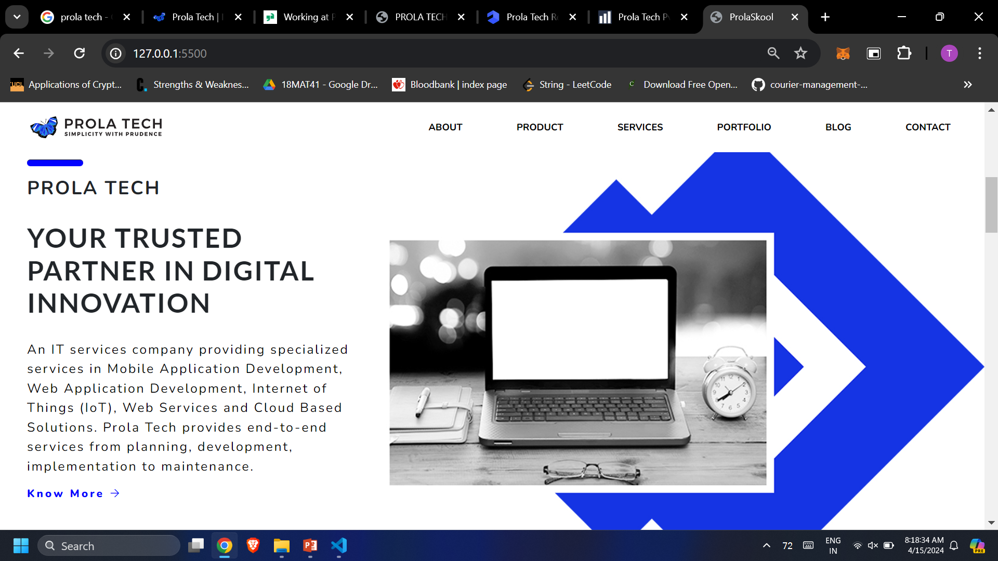

**Fig 3.1 Home Page of Company Website**

**3.3 Netflix Clone Website**

The HTML code presented outlines a webpage layout for a service named "HDO Box," designed to facilitate online streaming of TV shows and movies.

At the top, the head section defines metadata like the page title, character set, and viewport settings, along with a custom favicon. The header section introduces the page with a tagline and a call-to-action button for signing in, accompanied by a prompt for users to enter their email address to explore the service further.

The main content area showcases the service's features prominently. Sections detail the ability to enjoy content on various devices such as smart TVs and gaming consoles, as well as the convenience of downloading shows for offline viewing. Additionally, it emphasizes the platform's versatility, highlighting its compatibility with a range of devices, from smartphones and tablets to laptops and TVs.

Further down, a dedicated section addresses frequently asked questions (FAQs), providing users with quick answers to common inquiries they may have about the service's offerings and functionalities.

Lastly, the footer provides essential links to resources such as customer support, FAQs, and terms of use, ensuring users have access to comprehensive information and support options. Together, this HTML code structures a user-friendly landing page for "HDO Box," aimed at attracting users, addressing their queries, and guiding them through the service's features and functionalities.



**Fig 1:Home page**



**Fig 2:Dashboard page**

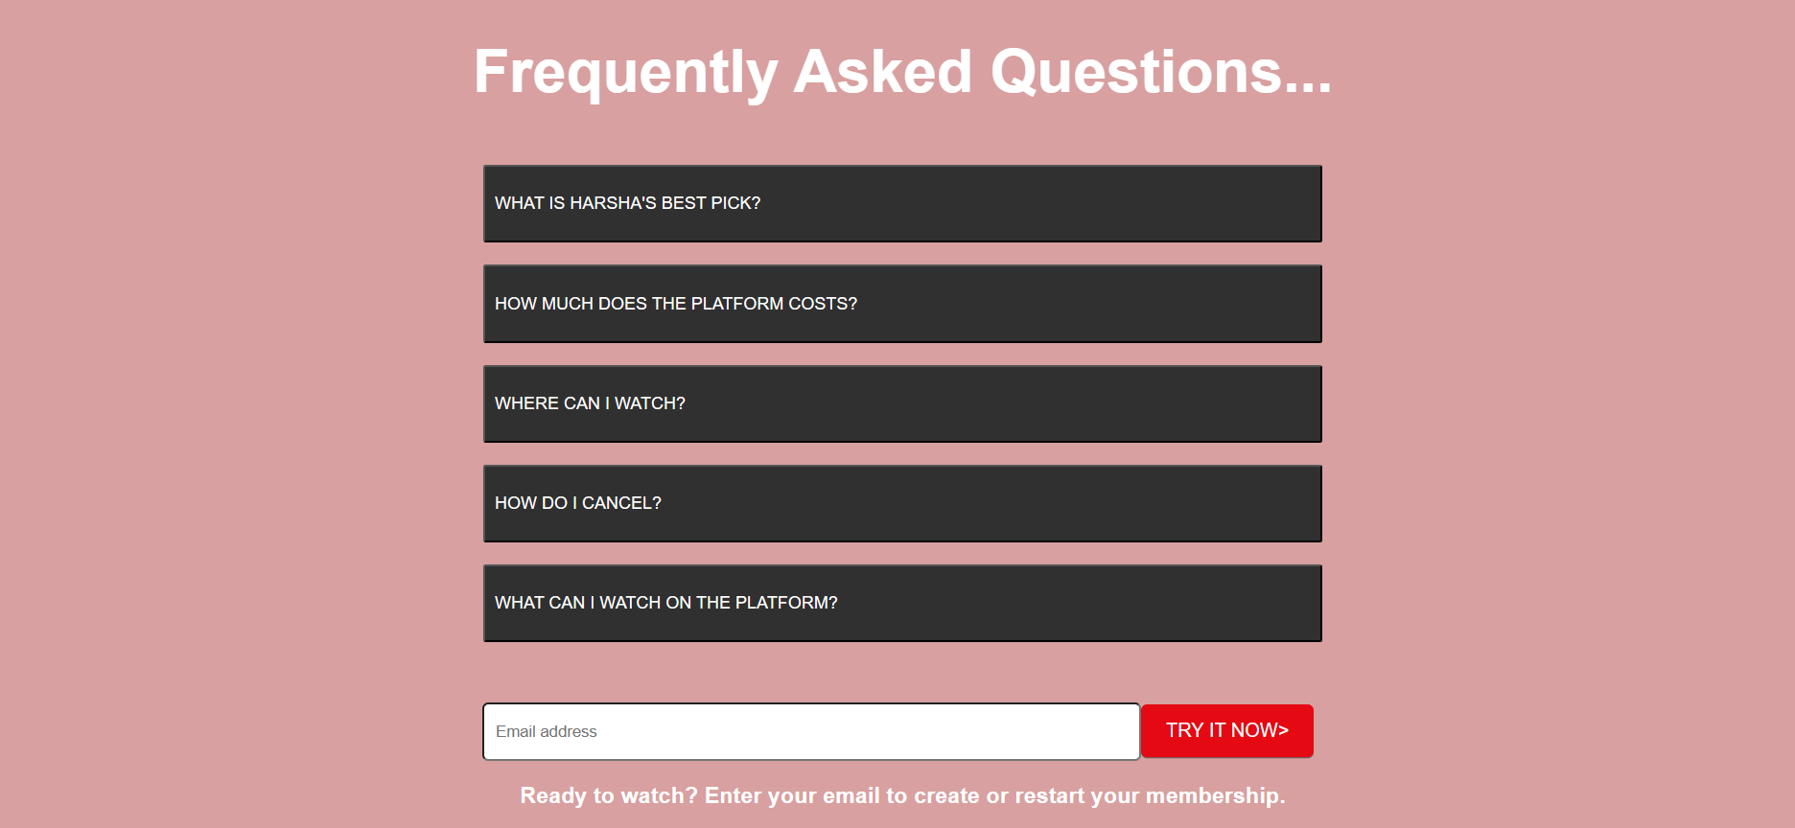

**Fig 3:** **FAQs Page**

**3.4 Part Time Workers Finder for Corporate Offices**

Our upcoming application seeks to address these pain points by providing a comprehensive platform that streamlines the entire process of engaging and managing local service providers. By leveraging technology and innovative solutions, our platform aims to connect corporate offices with a diverse range of service professionals, including cleaners, tea makers, plumbers, electricians, and more.

Our application aims to streamline how corporate offices engage local service providers, enhancing efficiency and transparency. By simplifying the process of finding, hiring, and managing service professionals like cleaners, plumbers, and electricians, we bridge the gap between businesses and service providers.

**1. User Management:**

Secure user registration and login, along with profile management, enable users to tailor their experience. Verification processes, including email and document verification, enhance trust and reliability**.**

**2. Service Provider Management:**

Service providers can showcase their skills and availability effectively. A comprehensive registration form, along with profile management functionalities, ensures that only qualified professionals are listed on the platform. A ratings and reviews system fosters accountability and continuous improvement.

**3. Corporate Office Management:**

Corporate offices can find nearby service providers based on location and services required, saving time and effort. The booking and scheduling system streamlines hiring, and integration with payment processing systems enables secure transactions.

**4. Location-Based Services:**

Geolocation technology enhances the user experience by providing proximity-based search functionalities. Real-time updates on service provider locations and availability, along with distance calculation and filtering options, refine search results for users.

I am currently working on the User Management module among four modules, By integrating features such as secure registration, profile verification, and personalized user interfaces, the User Management module contributes significantly to enhancing the overall experience for service providers, ultimately leading to increased satisfaction and success on the platform.

1. **Secure User Registration and Login:** This feature allows new users to sign up for the platform and existing users to log in securely. It typically involves creating an account with a unique username/email and password combination. Security measures such as encryption and captcha may be implemented to prevent unauthorized access.
2. **Profile Management:** Once users are registered, they can manage their profiles. This includes updating personal information, adding or modifying skills and expertise, uploading a profile picture, and setting preferences. A well-designed profile management system ensures that users can accurately represent themselves on the platform.
3. **Verification Processes:** To enhance trust and reliability within the platform, verification processes are crucial. This may include email verification, where users must confirm their email addresses to activate their accounts. Additionally, document verification can be implemented for certain types of users, such as service providers, where they may need to submit proof of qualifications or licenses. These verification processes help to weed out fake or fraudulent accounts and build confidence among users.

**CHAPTER 4**

**REFLECTION OUTCOMES**

**Chapter 4**

**REFLECTION OUTCOMES**

My internship at Prola Tech has been an enriching journey filled with valuable experiences and opportunities for growth. Throughout this period, I've not only contributed to the organization's projects but also developed essential skills and competencies that extend beyond technical expertise.

**4.1 Technical Outcomes**

During my internship, I've been actively involved in the development of the User Management Module for the Distance Learning app. This hands-on experience has allowed me to deepen my understanding of frontend and backend web development technologies. Specifically, I've gained proficiency in:

**1. Frontend Technologies**: I've worked extensively with HTML, CSS, and JavaScript to create interactive and user-friendly interfaces for the Distance Learning app. Through tasks such as designing registration forms, implementing navigation menus, and optimizing page layouts, I've honed my skills in frontend development and user interface design.

**2. Backend Technologies**: In addition to frontend development, I've delved into backend technologies such as Node.js to build robust server-side components for the User Management Module. This has involved tasks such as implementing user authentication and authorization mechanisms, designing database schemas, and developing RESTful APIs to facilitate data exchange between the frontend and backend layers.

**3. Version Control**: Throughout the development process, I've utilized version control systems such as Git to manage codebase changes and collaborate effectively with team members. By adhering to best practices for branching, merging, and code review, I've gained insights into the importance of version control in ensuring code quality and project stability.

Moreover, my internship experience has afforded me the opportunity to collaborate closely with my peers and mentors, engaging in code reviews, pair programming sessions, and knowledge sharing activities that have enriched my understanding of best practices and coding standards. This collaborative environment has not only accelerated my learning

curve but also fostered a sense of camaraderie and mutual support within the team, enabling us to overcome obstacles and achieve collective success.

In addition to technical proficiency, my internship has provided me with exposure to project management tools and methodologies such as Agile and Scrum. By participating in sprint planning, backlog grooming, and daily stand-up meetings, I've gained insights into the importance of collaboration, iteration, and adaptability in ensuring project success. These experiences have not only broadened my skill set but also instilled in me a mindset of continuous improvement and agility that will undoubtedly serve me well in my future endeavors in the field of software development.

**4.2 Non-Technical Outcomes**

Throughout my internship at Prola Tech, I've witnessed profound personal growth and development in various non-technical areas, each contributing significantly to my overall professional maturation and effectiveness.

**Improved Verbal and Written Communication:** The immersive nature of my internship has provided ample opportunities to refine my communication skills, both verbal and written, to a level of proficiency that exceeds my initial expectations. Through daily interactions with team members, stakeholders, and clients, I've honed the art of articulating complex technical concepts with clarity and coherence, ensuring that my messages resonate effectively across diverse audiences. Whether delivering concise project updates during team meetings, crafting comprehensive documentation to outline development processes, or providing constructive feedback to peers, I've cultivated a communication style characterized by precision, empathy, and adaptability. This newfound ability to convey ideas persuasively and concisely has not only enhanced my professional credibility but also fostered stronger relationships and collaboration within the team, laying the groundwork for sustained success in future endeavors.

**Personality Development**: My internship journey at Prola Tech has been more than just a professional endeavor; it has been a transformative experience that has shaped me into a more resilient, adaptable, and self-assured individual. Working in a dynamic and fast-paced environment has tested my limits and pushed me to embrace challenges with confidence and determination. Through moments of triumph and setbacks alike, I've discovered the resilience to persevere in the face of adversity, the adaptability to thrive in ever-changing circumstances, and the self-assurance to trust in my abilities and instincts. Moreover, I've developed a growth mindset that fosters continuous learning and self-improvement, propelling me towards new horizons of personal and professional development with unwavering enthusiasm and optimism.

**Time Management**: Balancing multiple tasks and deadlines has been a central theme of my internship experience, challenging me to refine my time management skills and adopt strategies for optimal productivity and efficiency. By meticulously planning and prioritizing tasks, setting realistic goals, and maintaining a disciplined work ethic, I've been able to navigate the complexities of project management with poise and precision. Moreover, I've learned to leverage time-saving techniques and tools to streamline workflows and maximize productivity without sacrificing quality or attention to detail. This newfound proficiency in time management has not only enhanced my ability to meet project objectives and deadlines consistently but also instilled a sense of confidence and control over my professional responsibilities, empowering me to tackle challenges with clarity and purpose.

**Resource Utilization Skills:** In an industry characterized by rapid innovation and technological advancement, the ability to leverage resources effectively is paramount for success. Throughout my internship, I've cultivated a keen eye for identifying and capitalizing on available resources, whether it's tapping into the collective expertise of my peers and mentors, leveraging existing code libraries and frameworks, or conducting independent research to address technical challenges. By harnessing the power of collaboration, creativity, and resourcefulness, I've been able to overcome obstacles and drive project progress with ingenuity and efficiency. Moreover, I've developed a mindset of resource optimization that extends beyond technical contexts, enabling me to make informed decisions and allocate resources judiciously in all aspects of my professional endeavors.

**CONCLUSION**

Concluding my internship journey at Prola Tech has been a transformative experience, providing me with a diverse skill set essential for success in software development. I have gained proficiency in web development technologies like HTML, CSS, Bootstrap, and JavaScript, while also developing crucial soft skills such as communication, time management, and resource utilization. This experience has prepared me to tackle future challenges with confidence. I have honed my technical abilities, including creating structured layouts and implementing responsive designs, while also cultivating essential soft skills like effective communication and adaptability. As I move forward, I am grateful for the opportunities at Prola Tech and look forward to applying these lessons and experiences in future endeavors, committed to continuous growth in the dynamic field of software development.

**REFERENCES**

[1] Prola Tech <https://www.prolatech.com/>

[2] BootStrap <https://getbootstrap.com/docs/5.3/getting-started/introduction/>

[3] https://w3schools.com/js/default.asp